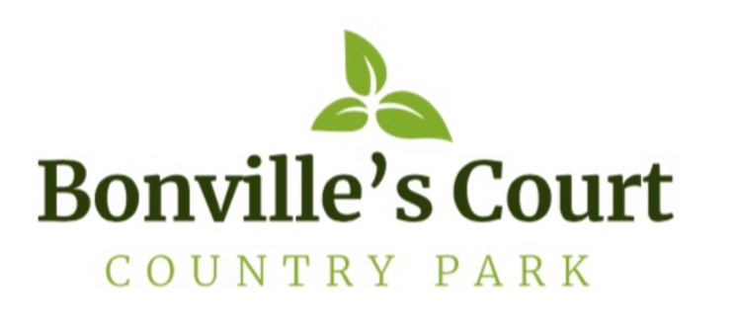
Corona-Virus/COVID-19

Procedures & Guidance for Visitors

We at Bonville’s Court Country Park take your safety and wellbeing serious, and for this reason all our accommodation will be/has been thoroughly cleaned throughout with:

- HYCLIN Antiviral Surface Cleaner (according to BS EN14476)
- Bleach mixture at a dilution of 1000 parts per million
- Finished off with fogging the accommodation throughout with an anti-virus disinfectant by Professional V2 Healthcare Super, tested to BS EN 14476, BS EN 1276 & BS EN 1367

On Arrival
Temperatures need to be taken!

- Please call 07770801503 when you are 10mins away or, when at St Clears roundabout. This
will allow us sufficient time to prepare our PPE to take your temperature.

- Temperatures need to be below 38°C - If your temperature is 38°C or above, it will be deemed that you have a fever, and potentially COVID-19.

- We have a duty of care to yourself, our staff and other users of the Park - If your temperature exceeds 38°C, you will be asked to leave, and advised to get a test.

- Checks all clear - If checks are all good, we will then escort you to your accommodation for your stay. When at the accommodation, we will leave you to enter the property unsupervised. Whilst there, please familiarise yourself with the property, read the Welcome Pack and user manuals. If you have any questions please call 07770801503

Check-in: After 5.30pm

During your stay

All facilities are closed, (Laundry Room, Gym, Spa, Sauna & Steam Rooms) until we are informed it is safe to reopen.

You are welcome to walk freely on the Park, at all times observing social distancing (2m) from other Park users and the Park Team. If you need to speak to any of our Park Team, please call 07770801503 and always observe social distancing (2m)

Please DO:

- Bring your groceries with you, if you can.
- Arrange for a delivery of groceries.
- Observe social distancing (2m) whilst in the community.
- Bring your own hand gel, soap, toilet roll, hand sanitiser with you, if you prefer.
- Enjoy yourselves in this beautiful area.

Please DO NOT:

- Meet or gather with friends in a social group, unless its outside and observing social distancing (2m).
- Invite or entertain visitors.
- Allow children to roam unsupervised around the Park so they do not, albeit inadvertently, break the social distance rule (2m).
- Leave your litter on the beach, please place it in the bins provided around the Harbour and Beach

Departure

Check-out By 09.30am

Before you leave, Please:

- Advise us whether you have/have not displayed signs of COVID19 by calling on 07770801503. According to the NHS website, the main symptoms are:

  - A high temperature
  - A new, continuous cough
  - A loss or change to your sense of smell or taste

- Strip beds and place sheets, pillow cases and any Towels (Tower Cottage & Sovereign Suite only), in the clear bags that have been provided for you
- Open all windows and leave front and back door open (unless it’s very windy/raining) and confirm with us by a call on 07770801503, that you have done so and that you have vacated the property.

We hope that you have enjoyed a relaxing time with us during these unprecedented times.

Please have a safe journey home and keep safe.

N.B.
It is not compulsory to wear facemasks/coverings in Wales, but it is advised.
Social distancing is still 2m in Wales

