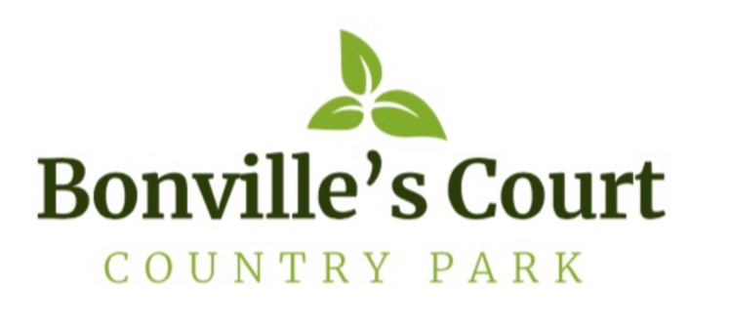
Corona-Virus/COVID-19

Procedures & Guidance for Caravan Owners

We at Bonville’s Court Country Park take your safety and wellbeing serious and of that of our Community and Park Team. For this reason, we have these procedures and guidance in place, and we thank you in advance for your continued support:

On 1st Arrival
Temperatures need to be taken!

- Please call 07770801503 when you are 10mins away or, when at St Clears roundabout. This will allow us sufficient time to prepare our PPE to take your temperature.

- Temperatures need to be below 38°C - If your temperature is 38°C or above, it will be deemed that you have a fever. You will also be asked if you have any symptoms. According to the NHS website, the main symptoms are:

  - A high temperature
  - A new, continuous cough
  - A loss or change to your sense of smell or taste

- We have a duty of care to yourself, our staff and other users of the Park - If your temperature exceeds 38°C, you will be asked to leave, and advised to get a test.

- Checks all clear - If checks are all good, we will then allow you to proceed to your caravan

- Away for more than 2/3 weeks - If you are away for more than 2/3 weeks from your caravan, you will need to have your temperature taking again.

During your stay

All facilities will be closed, (Laundry Room, Gym, Spa, Sauna & Steam Rooms) until we are informed it is safe to reopen.

You are welcome to walk freely on the Park, at all times observing social distance (2m) from other Park users and the Park Team. If you need to speak to any of our Park Team, please call 07770801503 and always observe social distancing (2m)

Please DO:

- Bring your groceries with you, if you can.
- Arrange for a delivery of groceries.
- Observe social distancing (2m) whilst in the community.
- Bring your own, hand gel, soap, toilet roll, hand sanitiser with you.
- Be patient when waiting in the local shops, cafés and restaurants, they have their own procedures for keeping you safe.
- Book in advance if you want to dine out at any of the fine places in this lovely area.
- Enjoy yourselves.

Please DO NOT:

- Meet or gather with friends in a social group, unless its outside and observing social distancing (2m).
- Invite or entertain visitors in your caravan.
- Allow children to roam unsupervised around the Park so they do not, albeit inadvertently, break the social distancing rule (2m).
- Leave your litter on the beach, please place it in the bins provided around the harbour and beach.

We hope that you can enjoy your caravan and have a relaxing time with us during these unprecedented times.

N.B.
- Social distancing rule in Wales is still 2m

- It is not compulsory to wear facemasks/coverings in Wales, but it is advised.

